The reactive dance play “THE WALL” - PROPOSAL DETAILS
NAME OF ARTIST/COMPANY | Insha Dance Company
CHOREOGRAPHER/DIRECTOR | Illia Miroshnichenko (choreographer\director)
SOCIAL MEDIA CHANNEL | Instagram : @insha_vystava
WEBSITE | https://www.inshatheatre.com
COUNTRY | Ukraine
TITLE OF PRODUCTION | “The Wall” Reactive dance play in one act
YEAR OF PREMIERE | 10.25.2021 (Kyiv, Ukraine)
LENGTH OF PERFORMANCE | 43-45 minutes
VIDEO LINK TO TRAILER | https://youtu.be/c7sq1msO_TI  https://youtu.be/-4xXl-5hQ3E
VIDEO LINK TO FULL LENGTH RECORDING WITH PASSWORD | https://youtu.be/luHJyNEriiM
NUMBER OF PEOPLE TRAVELING | 10 persons
NECESSARY SIZE OF VEHICLE | The truck with a loading capacity minimum of 3 tons and sizes not less than 4.2m(length)-2m(width)-2m(height).
NAME OF CONTACT PERSON | Illia Miroshnichenko
EMAIL ADDRESS OF CONTACT PERSON | iliamiroshnichenko@icloud.com
PHONE NUMBER OF CONTACT PERSON | +380631594503  (WhatsUp, Telegram, Viber etc.)
BRIEF TECHNICAL INFO (STAGE SIZE AND TYPE IF STAGE WORK, SPACE REQUIREMENT, SETUP TIME,ETC.)
• Black Box stage set or possibility to use stage back wall as a background.
• 6 meters height minimum (the visible part). The rise of bars is not less than 14 meters. On each side of the stage it is necessary to have black backdrops (at least 2 plans), the presence of black panes (at least 3), it is necessary to have a white screen for the front projection. In case the stage doesn`t have enough height or second height at all there is alternative variant of the play (https://youtu.be/5c_cXEryAJ0 ). The presence of an opening and closing curtain is required
• The stage covering is to be made of black ballet linoleum, with ballet scotch tape for pasting the linoleum.
• It is obligatory to have 7 free bars for hanging scenery, projectors and lighting devices, not counting bars occupied (curtains, paduges) under the black cabinet. All bars not occupied in the performance should be released from all hangers, and maximally lifted upwards, on fly gallery. Scheme of the suspension of lighting equipment is attached. In case the stage doesn`t have enough bars at all there is alternative variant of the play.
• One ironing board
•Setup time minimum 6 hours the day before show (if it possible). It contains: 2 hours of stage scenery settings up, minimum 2 hours of light rehearsal, 2 hours dance rehearsal with sound check. The technical details adds to the letter.

SHORT DESCRIPTION OF ARTWORK

Reactive Dance Play “The Wall” is a collaboration between choreographer Illia Miroshnichenko and sound -artist Heinali (Oleg Shpudeiko). The perfomance explores the archetype of the wall in its various manifestations, including the wall as an obstacle in communication between dance and music. With the help of a reactive surface and a modular synthesizer, dancers create music, and music, in turn, shapes the movements of the dancers. The production refers to a series of situations built around the idea of the wall and borrowed from history, religion, myths and personal experiences.

The perfomance evening consists of two parts . The first part is the short documentary film “Behind the Wall” (English subtitles) where the participants of the project explain how the reactive technology works, and share their feelings from working with the Wall. The second part is a Dance Play “The Wall” itself.

Stage set details

- 6 square blocks 2,25m x 2,25m x 0,25m each as lead set. Every block has two parts (2,25m x 1,125m x 0,25m) for transferring.

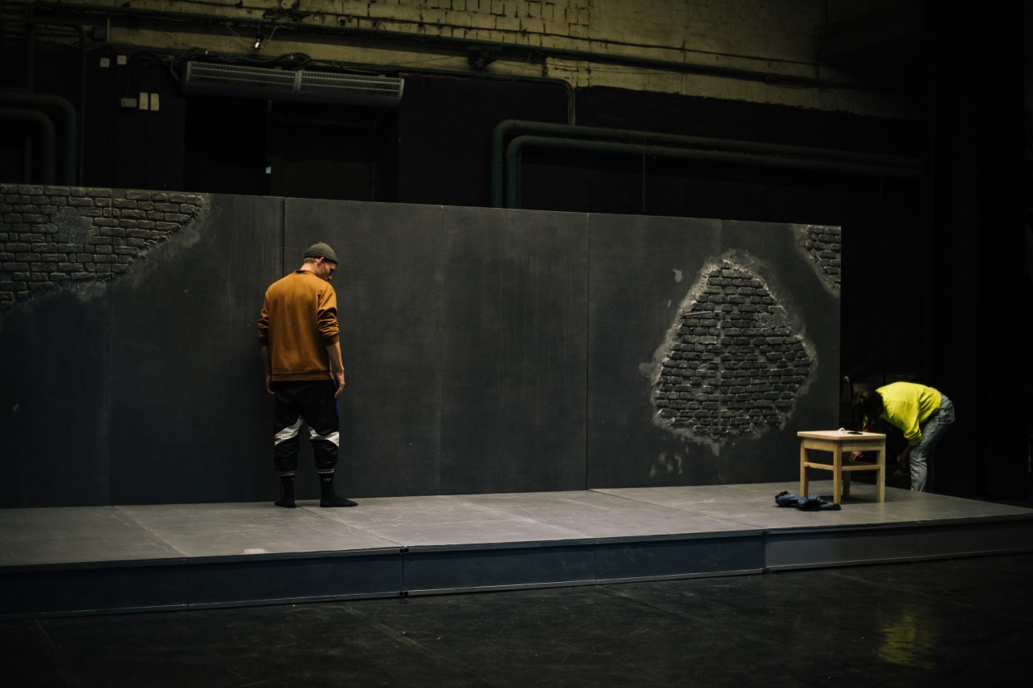

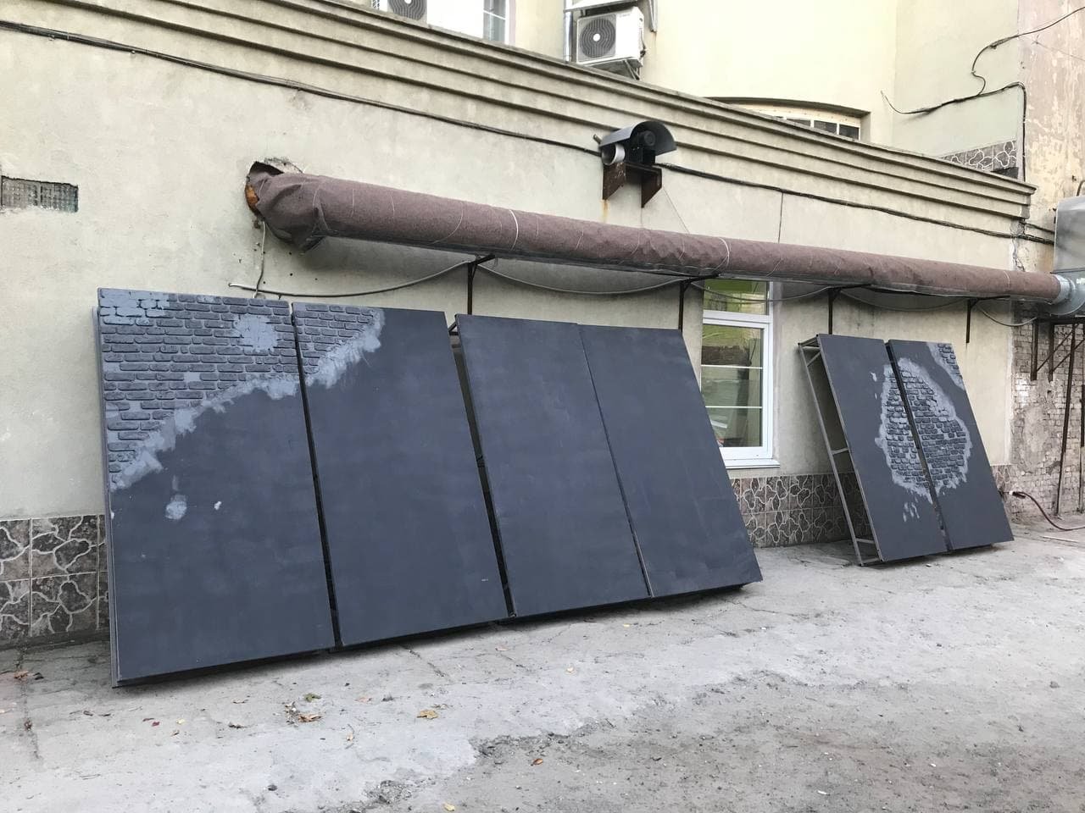

- 2 blocks 1,5m x 1m x 1m each for background (behind the wall) work space at least 1,5 m.

- 3 different panels as additional small walls (for rising bars on stage) not bigger than 2,75m x 2,5m x 0,2m each

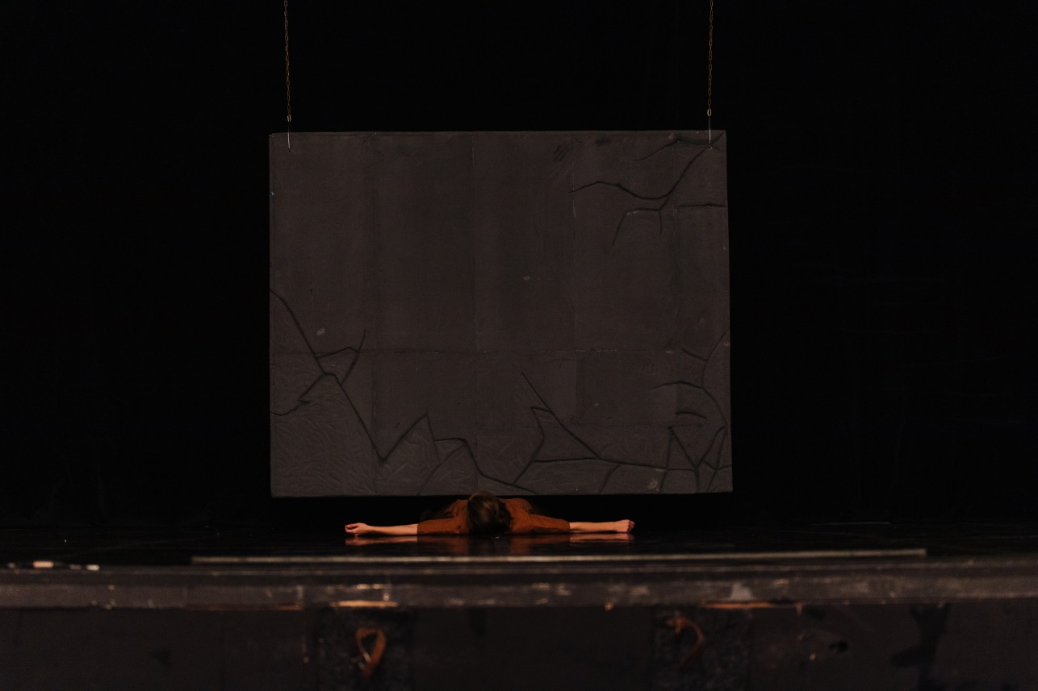

- 4 bamboo sticks 1,25 m height

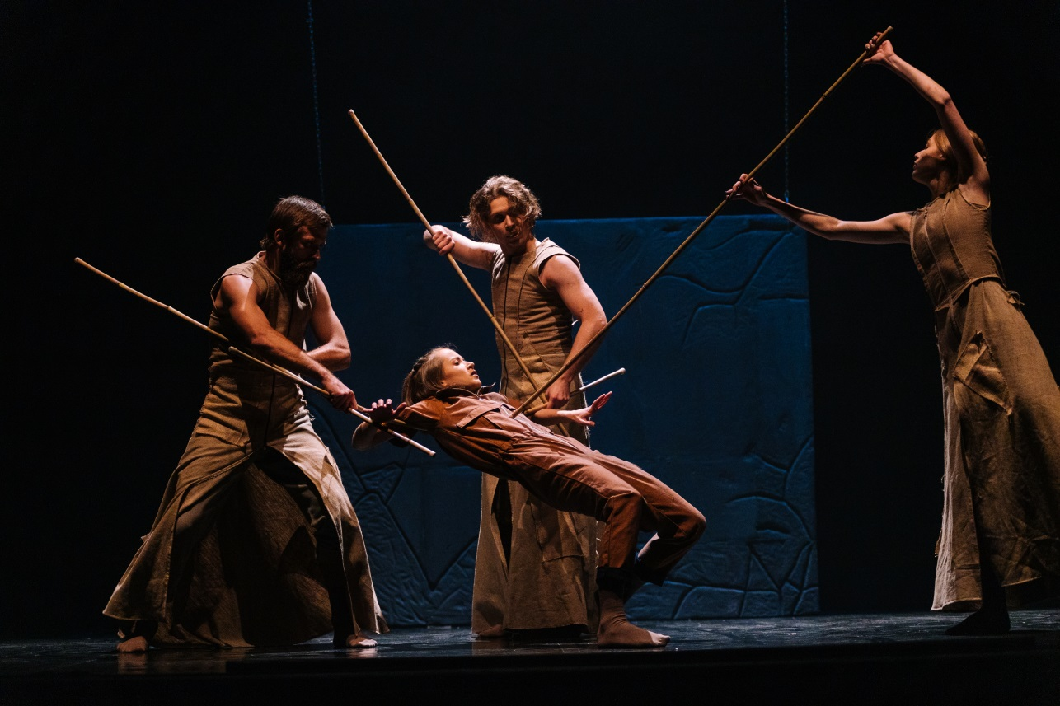

- 1 special chair with hard construction design for mounting it on the wall.

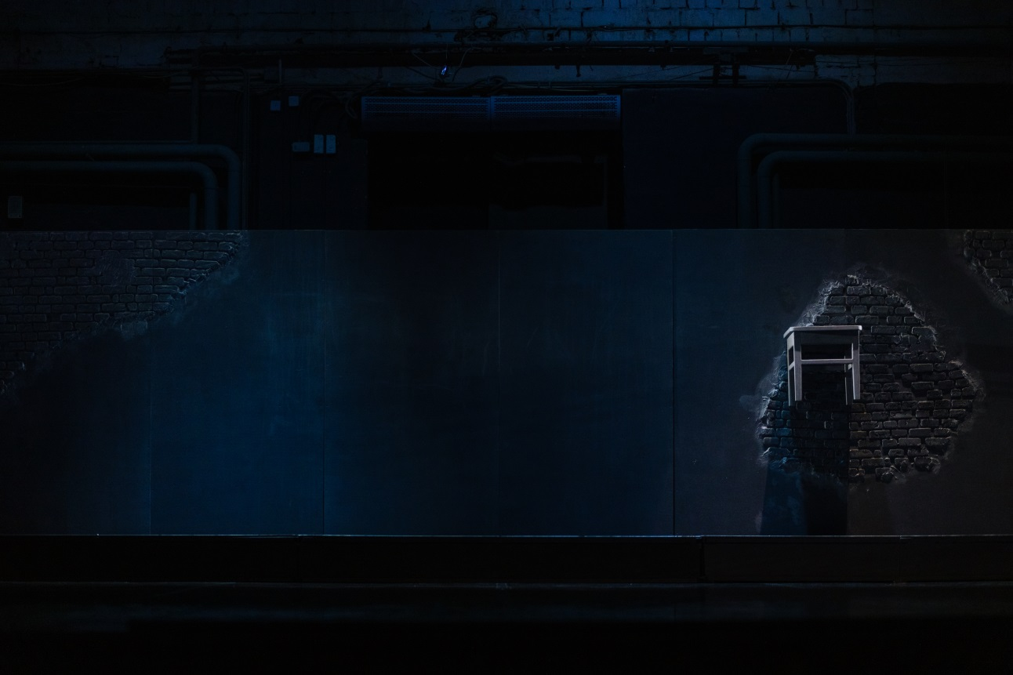

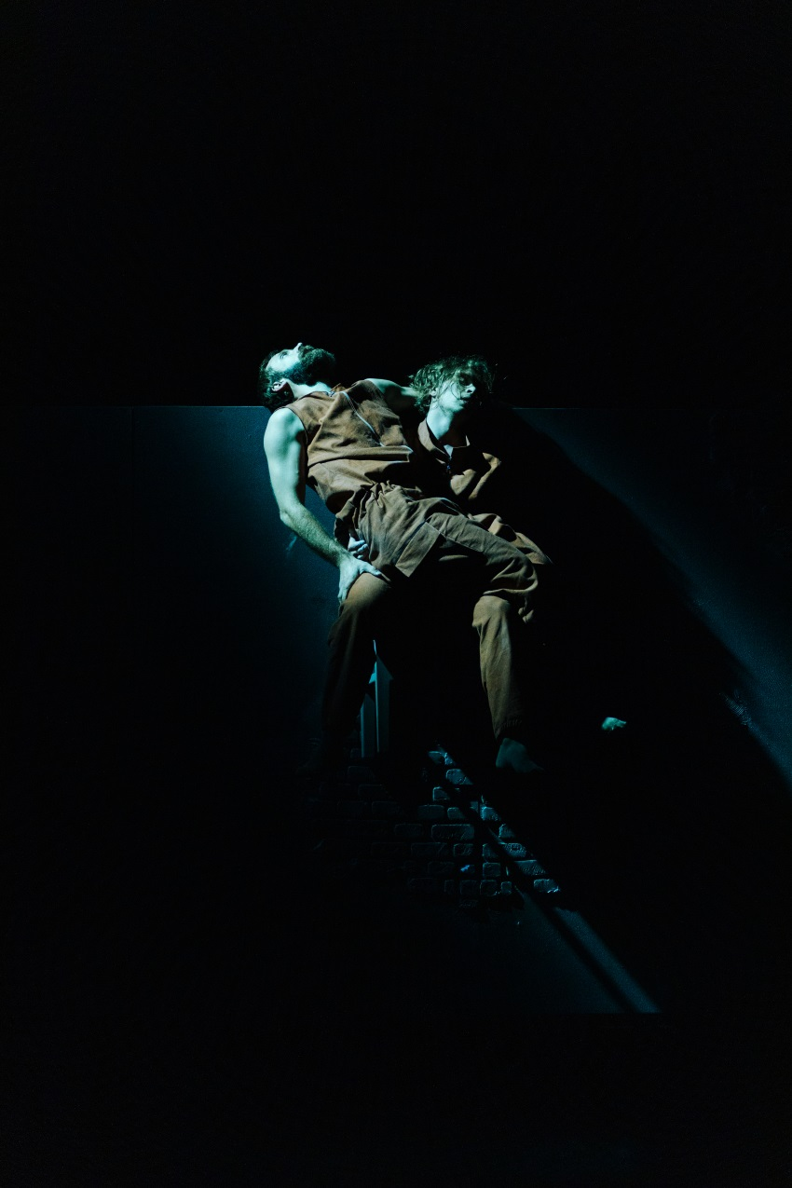

- 1 small cube box 0,20m x 0,20m x 0,20m with special designed contact microphone on it

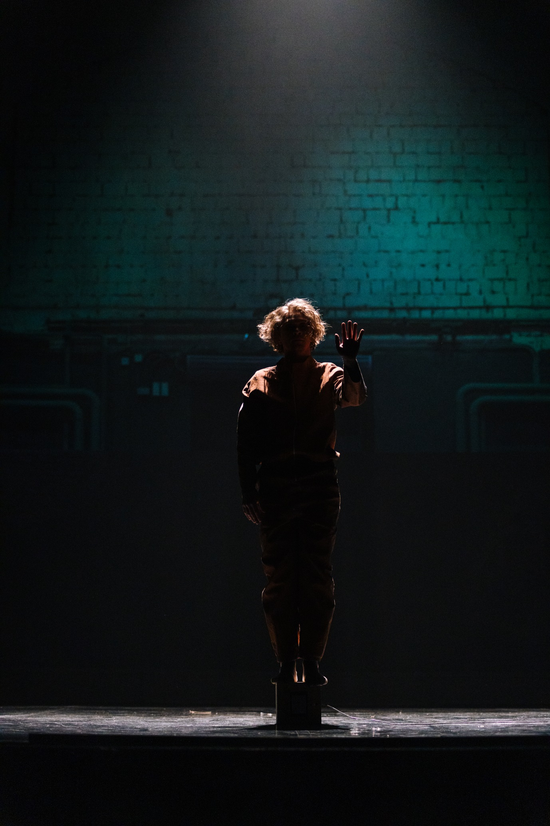

- 3 knit balls

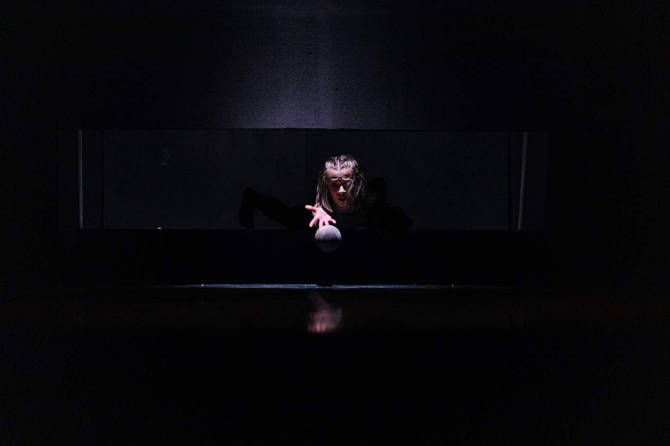

- 1 table for the musician on stage for setting the modular synth

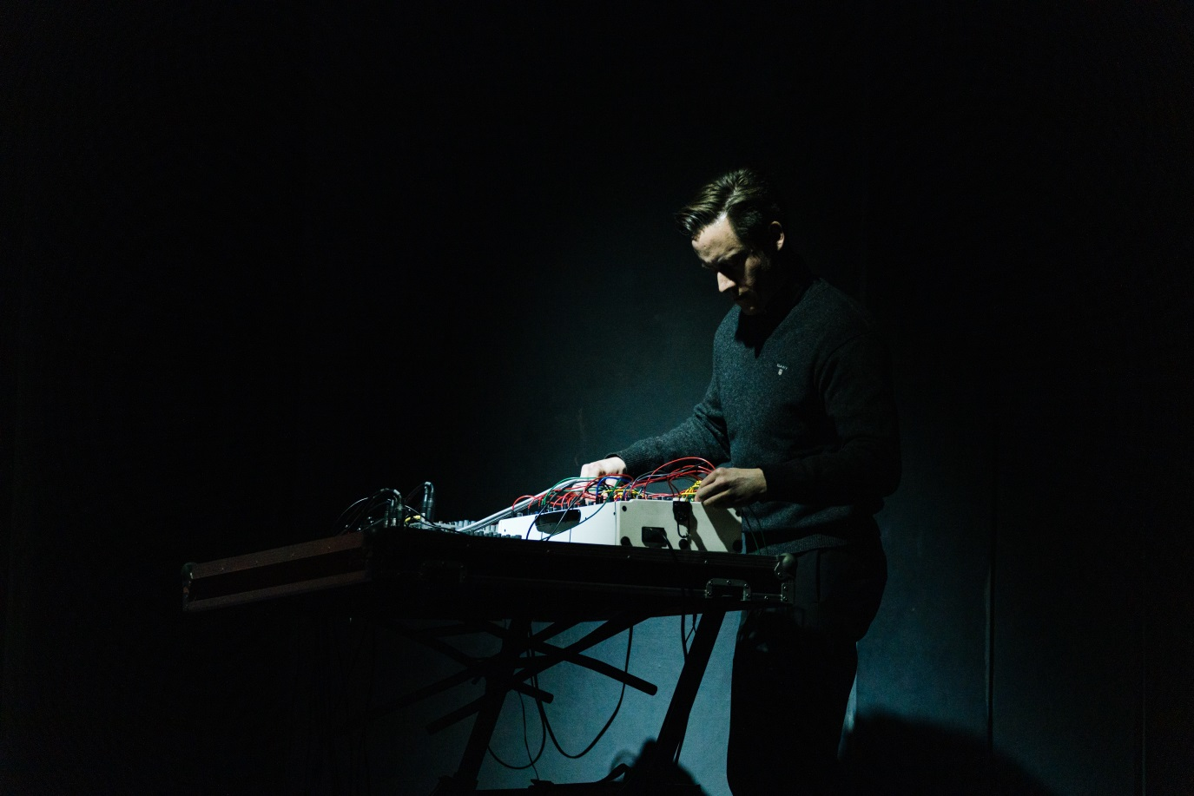

Sound details

For the successful show inviter undertakes to provide:
- ONE 12 channels mixing console or TWO 6 channels mixing console for using it on stage by musician
- 14 XLR (in/out) wires minimum 10 meters each to connect ours microphones with console.
- ONE multi power outlet (rosette) on stage for using by musician.
- Local sound designer for turning on our sound into main line on stage.

